How to create a Word Cloud

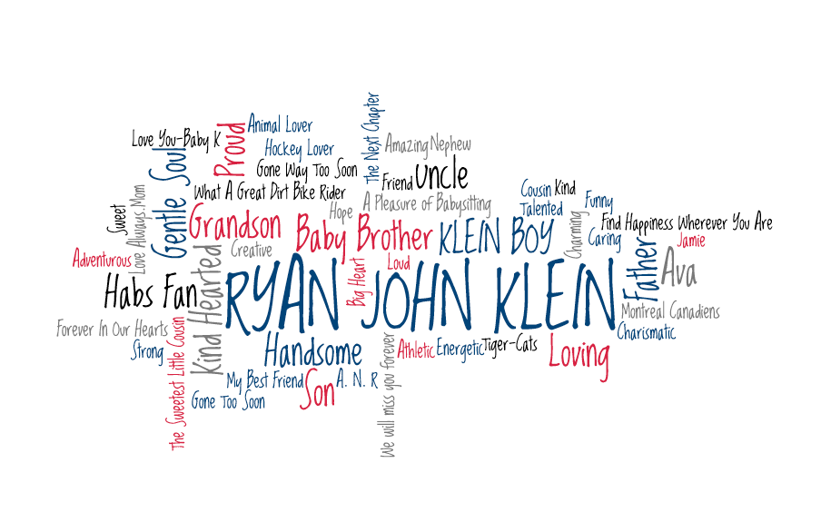

How to get started.
To create A Word Cloud, we use the program wordle.net (Website is www.wordle.net ). We have found the internet browser “Firefox” most compatible with wordle.net. Wordle.net uses the Java browser plugin. Verify that Java is installed properly, and that your web browser is configured to permit its use. Wordle.net also has a FAQ tab for troubleshooting.

Create a list of words in a “Word” document
It helps if you create a list of words in a Word document and save them. On many occasions, the list of words keeps growing or words require minor adjustments. You can’t edit in wordle.net and it doesn’t allow you to go back.

The size of a word in the visualization is proportional to the number of times the word appears in the list of words. So, for example, if you type:

Ryan~John~Klein
Ryan~John~Klein
Ryan~John~Klein
Baby~Brother
Baby~Brother
Kind

You can see from the example above that Ryan John Klein’s font size is largest, Baby Brother is slightly smaller and Kind is smallest. The higher the frequency of a single word, the larger it will appear in the image.

To keep words together you can use either the dash “ – “ i.e Tiger-Cats or the tilde character ~ between words that go together. The tilde will be converted to a space when drawing the words, and the words will be treated as a single word.

Creating the Word Cloud

1. Copy the list of words from your Word document

2. Open www.wordle.net and select the link “Create your own”

3. Paste the list of words into the box and select the link “go”. If the site is not loading, ensure you have Java installed and activated (the website will usually prompt you if this is not the case).

4. The program will create a Word Cloud. You can edit the Language, Font, Layout and Color.

5. Suggested settings: Language (Leave words as spelled), Font (Loved by the King), Layout (Rounder Edges and Mostly Horizontal), Color (Kindled or Shooting Star; Edit Custom Palette is also fun!)

6. To change the shape select Layout (Re-layout with current setting)

7. To change the color (the shape will stay the same) select Color (Recolor)

8. When you like a Word Cloud image, select the “Print” image, PDF (bottom left corner), Save as PDF. If that option does not work or is not available on your computer, click “Mail as PDF” and then you can save the PDF file that will open in an email.

9. Enjoy the Word Cloud. Print it, frame it, make it a screen saver, upload it on Facebook, etc.

Tips:
- Make sure the person's name has the highest frequency and will therefore appear largest (this offers the best visual effect). It looks best if the first and last name are both horizontal. You might like the name to be either towards the left or central in the image.
- Make sure that words which are close together don’t look like they are part of a phrase. If this happens, but you love the layout, refresh the color scheme so the coloring of these words makes them look more unique.
- To remove a word, right click on the word as it appears in the cloud and select “remove”. This will remove the word and re-shuffle the remaining words.
- Experiment with word size (refer back to your saved Word file and make changes as needed).
- Refresh the Word Cloud until you get the perfect image by clicking “Relayout with current settings” in the Layout tab and/or “Recolor” in the Color tab). When you find a layout/color combination that you like, go to the bottom of the screen and click “Print”.
- Make sure you save all drafts of the Word Cloud that you like, because once you refresh the layout, it is gone forever!

